supplement
Statistical Process Control

Discussion Questions
1. Shewhart’s two types of variation: common and special causes are also called natural and assignable variation.
2. A process is said to be operating in statistical control when the only source of variation is natural or common causes.
3. The x-bar chart indicates whether changes have occurred in the central tendency of a process; the R-chart indicates whether a gain or a loss in uniformity has occurred.
4. A process can be out of control because of assignable variation, which can be traced to specific causes. Examples include such factors as:
- Tool wear
- A change in raw materials
- A change in working environment (temperature or humidity, for example)
- Tired or poorly trained labor
5. The 5 steps are:
1. Collect 20 to 25 samples, often of n = 4 or 5 each; compute the mean and range of each sample.
2. Compute the overall means ( and ), set appropriate control limits, usually at the 99.73% level, and calculate the preliminary upper and lower control limits. If the process is not currently stable, use the desired mean, μ, instead of to calculate limits.
3. Graph the sample means and ranges on their respective control charts and determine whether they fall outside the acceptable limits.
4. Investigate points or patterns that indicate the process is out of control. Try to assign causes for the variation,
address the causes, and then resume the process.
5. Collect additional samples and, if necessary, revalidate the control limits using the new data.
6. Text list includes machine wear, misadjusted equipment, fatigued or untrained workers, new batches of raw materials, etc. Others might be bad measuring device, workplace lighting, other ergonomic conditions etc.
7. Two sigma covers only 95.5% of all natural variation; even in the absence of assignable cause, points will fall outside the control limits 4.5% of the time.
8. The desired mean is used when the mean of a process being observed is unknown or out of control or when there is an established
or known μ, provided by the manufacturer or designer of the
equipment or process.
9. Yes; “out of control” means that the process has changed. If we are doing something “too well,” then the process has changed from the norm. We want to find out what we are doing “too well” so that we can do the same thing in the future and for other products.
10. Control charts are designed for specific sample sizes because the sample standard deviation or range is dependent on the sample size. The control charts presented here should not be used if the sample size varies.
11. Cpk, the process capability index, is one way to express process capability. It measures the proportion of natural variation (3σ) between the center of the process and the nearest specification limit.
C_{p} is the process capability ratio and determines if the pro-
cess meets design specifications.
12. A “run of 5” implies that assignable variation is present.
13. The AQL is the quality level of a lot considered to be good. The LTPD is the quality level of a lot we consider bad. These
are combined with risk levels to determine an acceptance sampling plan.
14. A run test is used to help spot abnormalities in a control chart process. It is used if points are not individually out of control, but form a pattern above or below the nominal (center) line.
15. Managerial issues include:
- Selecting places in a process that need SPC
- Deciding which type of control charts best fit
- Setting rules for workers to follow if certain points or patterns emerge
16. An OC curve is a graph showing the probability of accepting a lot given a certain quality (percentage of defective).
17. The purpose of acceptance sampling is to determine a course of action (accept or reject) regarding the disposition of a lot without inspecting each item in a lot. Acceptance sampling does not estimate the quality of a lot.
18. The two risks when acceptance sampling is used are type I error: rejecting a good lot; type II error: accepting a bad lot.
19. A process that has a capability index of one or greater—a “capable” process—produces small percentages of unacceptable items. The capability formula is built around an assumption of
exactly one, those parts that are more than three sigma from center are unacceptable; they are 0.00135 of all output. If the capability index is greater than one, that fraction falls.
Active Model Exercises*
Active Model S6.1: p-Chart—with data
1. Has the the process been in control?
Samples 3 and 19 were “too good,” and sample 16 was out of control.
2. Suppose we use a 95% p-chart. What are the upper and lower control limits? Has the process gotten more out of control?
.074 and .0008. It is the same process but sample 13 is also out of control.
3. Suppose that the sample size used was actually 120 instead of the 100 that it was supposed to be. How does this affect the chart?
The overall percentage of defects drops and, in addition, the UCL and LCL get closer to the center line and each other.
4. What happens to the chart as we reduce the z-value?
The chart gets “tighter.” The UCL and LCL get closer to the center line and each other.
5. What happens to the chart as we reduce the percentage
defects?
The chart gets “tighter.” The UCL and LCL get closer to the center line and each other.
Active Model S6.2: Process Capability
1. How far can the mean shift to the right before the curve extends over the upper specification? How does this affect the Cp and Cpk?
Approximately 1.45; Cp is not affected; Cpk is about 1.0.
2. Increase the standard deviation. At what value will the curve cross the upper specification?
About .9
Active Model S6.3: Acceptance Sampling/OC Curve
1. What is the designed value for alpha? What is the actual value for alpha?
designed = .05; actual = .0492
2. What is the designed value for beta? What is the actual value for beta?
designed = .10; actual = .0525
3. What happens to the appropriate sampling plan as the AQL is increased?
Both the sample size and critical value increase.
4. What happens to the actual alpha and beta as the LTPD is increased?
Alpha remains the same and beta decreases.
5. What happens to the actual alpha and beta as the sample size, n, is increased?
Alpha increases and beta decreases.
6. What happens to the actual alpha and beta as the critical value, c, is increased?
Alpha decreases and beta increases.
End-of-Supplement Problems
*These Active Models are found on our Companion Web site, at www.pearsonhighered.com/heizer.
S6.1
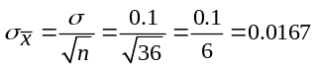
μ = 14 oz.
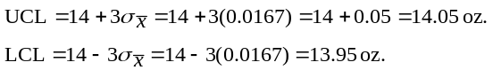
S6.2(a) 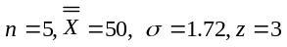
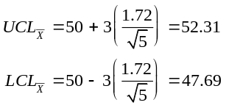
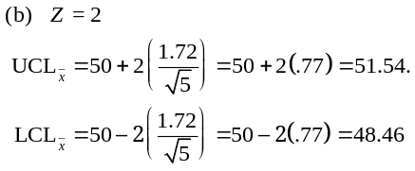
The control limits are tighter, but the confidence level has dropped.
S6.3 The relevant constants are:
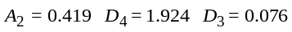
The control limits are:
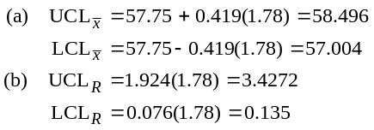
S6.4 Target of 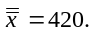 So
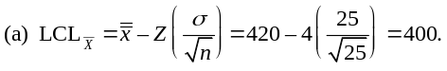
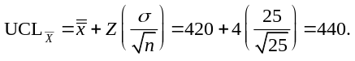
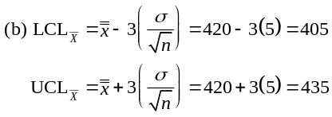
S6.5 From Table S6.1, A2 = 0.308, D4 = 1.777, D3 = 0.223
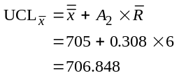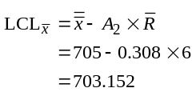
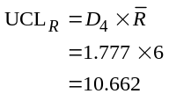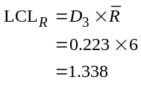
S6.6

Hour |  | R | Hour |  | R | Hour |  | R
1 | 3.25 | 0.71 | 9 | 3.02 | 0.71 | 17 | 2.86 | 1.43
2 | 3.10 | 1.18 | 10 | 2.85 | 1.33 | 18 | 2.74 | 1.29
3 | 3.22 | 1.43 | 11 | 2.83 | 1.17 | 19 | 3.41 | 1.61
4 | 3.39 | 1.26 | 12 | 2.97 | 0.40 | 20 | 2.89 | 1.09
5 | 3.07 | 1.17 | 13 | 3.11 | 0.85 | 21 | 2.65 | 1.08
6 | 2.86 | 0.32 | 14 | 2.83 | 1.31 | 22 | 3.28 | 0.46
7 | 3.05 | 0.53 | 15 | 3.12 | 1.06 | 23 | 2.94 | 1.58
8 | 2.65 | 1.13 | 16 | 2.84 | 0.50 | 24 | 2.64 | 0.97
Average = 2.982, Average R = 1.02375, n = 4. From Table S6.1, A2 = 0.729, D4 = 2.282,
D3 = 0.0.

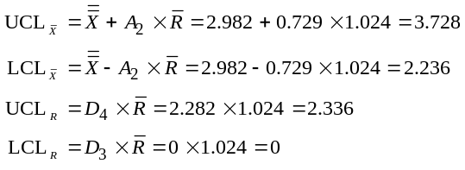
The smallest sample mean is 2.64, the largest 3.39. Both are well within the control limits. Similarly, the largest sample range is 1.61, also well within the control limits. We can conclude that the process is currently within control. However, the first five values for the mean are above the expected mean; this may be the indication of a problem in the early stages of the process.

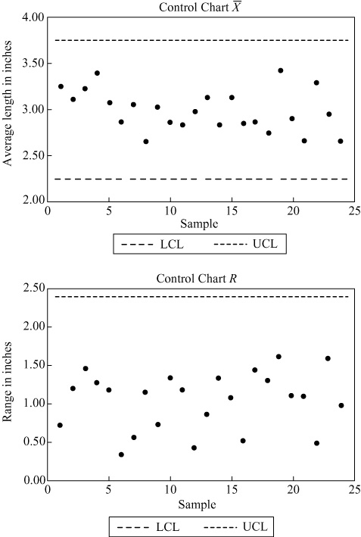

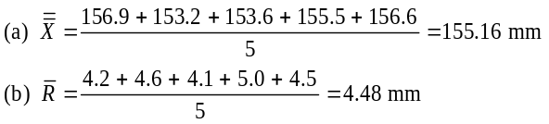S6.7
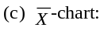
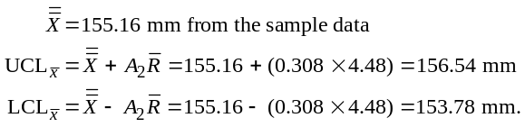
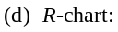
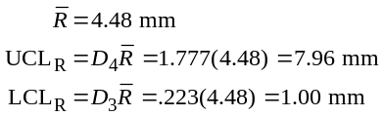
(e) If the desired nominal line is 155 mm, then:
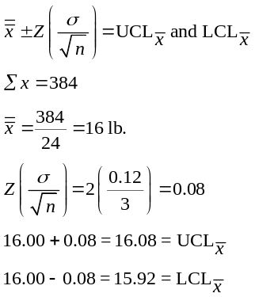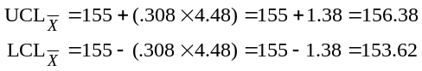
S6.8 (a)

(b) With z = 3,
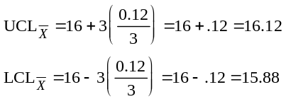
The new limits are set for 99.73% confidence and hence are wider.

S6.9 The process is no longer in control. Sample 3 lies outside the range limits; Samples 3 and 5 are outside the mean limits. The assignable causes should be determined and eliminated. Perhaps there is a new baker’s assistant who lacks good judgment about weight of the loaves.
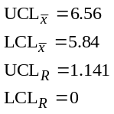
 | Mean | Range
Sample 1 | 6.025 | 0.4
Sample 2 | 6.05 | 0.4
Sample 3 | 5.475 | 1.5
Sample 4 | 6.075 | 0.3
Sample 5 | 6.625 | 0.4

S6.10 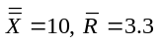
(a) Process (population) standard deviation (σ) = 1.36,
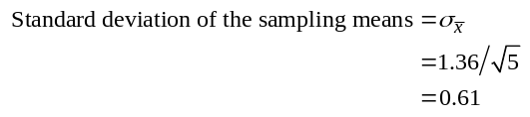

(b) Using 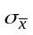
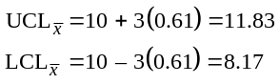
Using A2 = 0.577
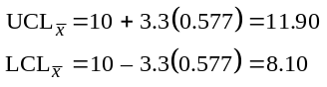
(c) UCL_{R} = 2.115(3.3) = 6.98
LCL_{R} = 0(3.3) = 0
(d) Yes, both mean and range charts indicate process is in control.
S6.11
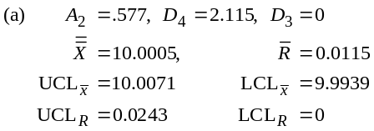
(b)
Original Data
 |  |  | Are Both the Mean
 | Sample |  | and Range
Sample | Mean (in.) | Range (in.) | in Control?
1 | 10.002 | 0.011 | Y
2 | 10.002 | 0.014 | Y
3 | 9.991 | 0.007 | N
4 | 10.006 | 0.022 | Y
5 | 9.997 | 0.013 | Y
6 | 9.999 | 0.012 | Y
7 | 10.001 | 0.008 | Y
8 | 10.005 | 0.013 | Y
9 | 9.995 | 0.004 | Y
10 | 10.001 | 0.011 | Y
11 | 10.001 | 0.014 | Y
12 | 10.006 | 0.009 | Y
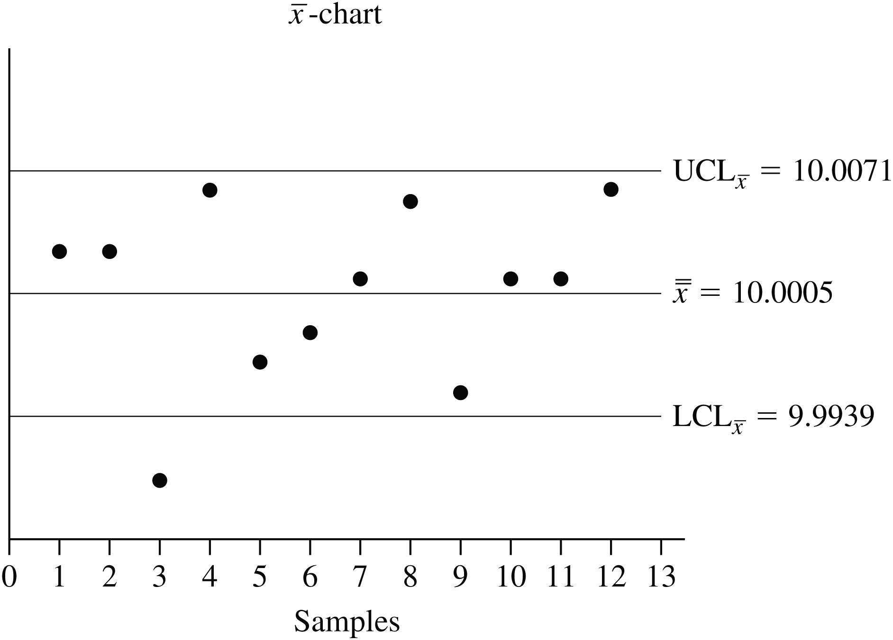

All range chart data points are inside their control limits.

c) The mean for sample 3 is outside of the lower limit. The reason for this outlier should be investigated, the causes eliminated, and the process studied again and new limits set.
(d) If the instructor wishes to illustrate the concept of setting valid control limits, he/she can have the students eliminate out of control points. The correct process is to eliminate the range outliers first. Here there are none. If we eliminate the offending sample number 3, the recomputed limits would be:
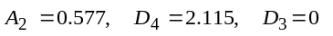
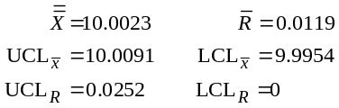

Revised Control Limits
 |  |  | Are both the Mean
 | Sample |  | and Range
Sample | Mean (in.) | Range (in.) | in Control?
1 | 10.002 | 0.011 | Y
2 | 10.002 | 0.014 | Y
3
4 | 10.006 | 0.022 | Y
5 | 9.997 | 0.013 | Y
6 | 9.999 | 0.012 | Y
7 | 10.001 | 0.008 | Y
8 | 10.005 | 0.013 | Y
9 | 9.995 | 0.004 | Y
10 | 10.001 | 0.011 | Y
11 | 10.001 | 0.014 | Y
12 | 10.006 | 0.009 | Y
These limits reflect a process that is now in control.
S6.12 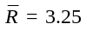mph, Z = 3,with n = 8, from Table S6.1, D₄ = 1.864, D₃ = .136
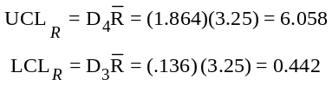

Note that in this problem much more information is provided than the student needs to compute the answer.
S6.13
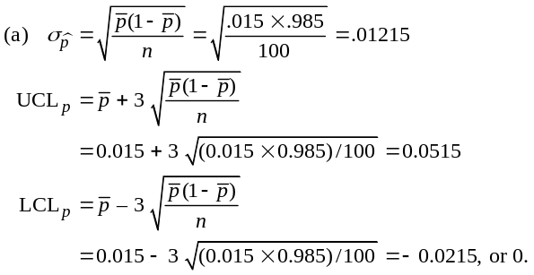
(b) n = 50, z = 3
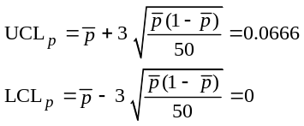

(c) n = 100, z = 2
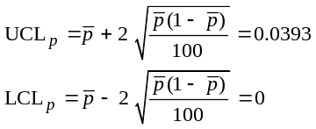
(d) n = 50, z = 2
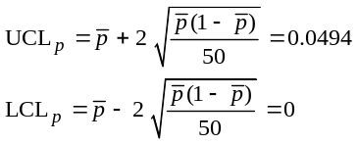
(e) When the sample size increases,
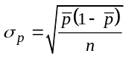 is smaller.
(f) The LCL can reach as low as zero but cannot be negative because it is not physically possible to have less than 0% defective.
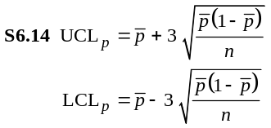
Percent |  | n = 100
Defective () | 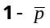 | 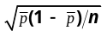 | LCL_{P} | UCL_{P}
0.02 | 0.98 | 0.014 | 0.0 | 0.062
0.04 | 0.96 | 0.020 | 0.0 | 0.099
0.06 | 0.94 | 0.024 | 0.0 | 0.132
0.08 | 0.92 | 0.027 | 0.0 | 0.161
0.10 | 0.90 | 0.030 | 0.01 | 0.190

S6.15 (a) The total number defective is 57.
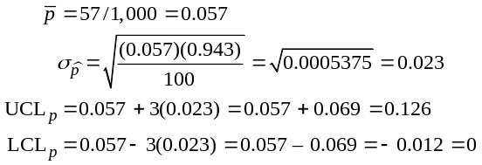
(b) The process is out of control on the third day (of the next 3 days).
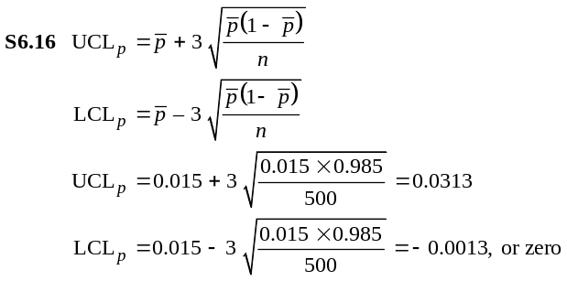
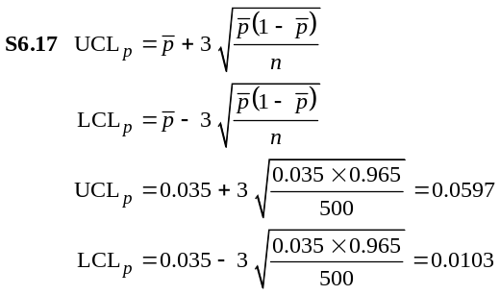
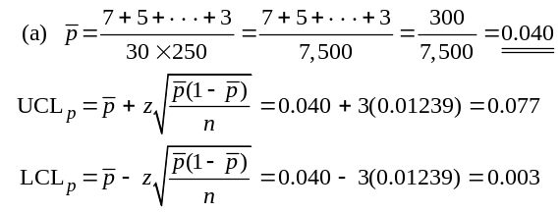S6.18

(b) The LCL cannot be negative because the percent defective can never be less than zero.
(c) The industry standards are not as strict as those at Georgia Bank. Georgia Bank sets its upper control limit at 0.077 = 7.7% defective, while the industry allows as high as 10% before claiming that the sample is out of control.

S6.19 = Total number of unsatisfied patients/Total number
surveyed = 122/700 = 0.1743
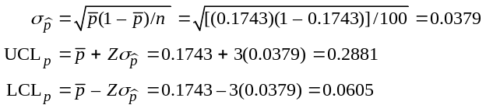
Analyzing the p chart, we see that there are no points that fall out-side of the control limits. However, we can see that on day 6 the number of unsatisfied patients is approaching the upper limit. The hospital might note the meal served that day and monitor future patient feedback on those menu items.
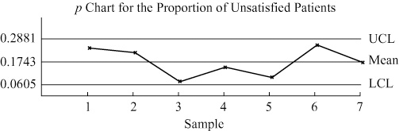
S6.20 (a) n = 200, = 50/10(200) = 0.025
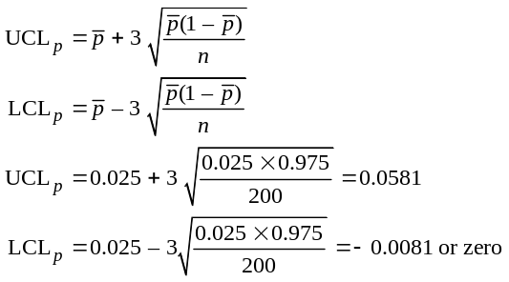

(b) The highest percent defective is .04; therefore the process is in control.
(c) If n = 100, 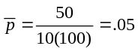
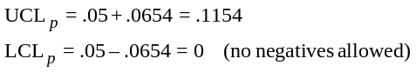
These are less strict control limits than in part (a), so the conclusions do not change.
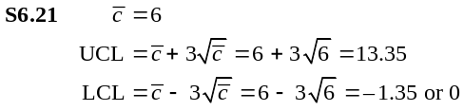
Nine returns are within the control limits; so this many re-turns would not be considered unusual.
S6.22 (a) We are counting attributes and we have no idea how many total observations there are (the proportion of drivers who weren’t offended enough to call!) This is a c-chart.
(b) Use mean of 6 weeks of observations 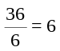 for
as true is unknown.
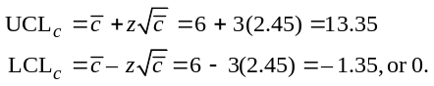

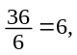 (c) It is in control because all weeks’ calls fall within interval of [0, 13].
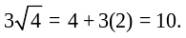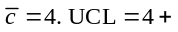 (d) Instead of using we now use
LCL = 4 – 3(2) = –2, or 0. Week 4 (11 calls) exceeds UCL. Not in control.
S6.23
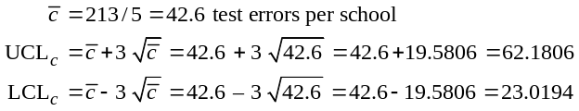
The chart indicates that there are no schools out of control. It also shows that 3 of 5 schools fall close to or below the process average, which is a good indication that the new math program has been taught as effectively at one school in the county as another.
Whether or not the new math program is effective would require comparisons of this year’s test results with results from previous years (under the old program) or comparisons with national per-formance data.
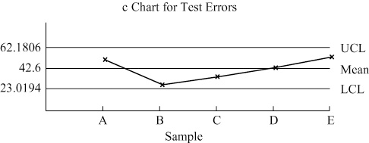
S6.24
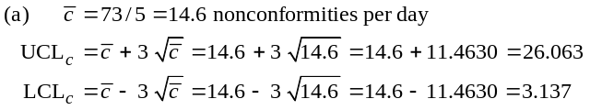
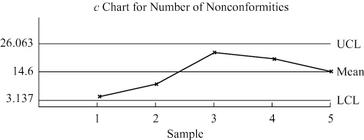
(b) The c chart shows us that there is no significant variation in the incidents of incorrect information given out by the IRS telephone operators. (Thus all the operators are equally misinformed!) It does not tell us about the consequences of the incorrect information provided, nor does it judge whether an average of almost 15 errors a day is acceptable to the IRS.
S6.25
(a)
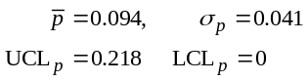
 | No. of |  | Is the Billing
Sample No. | Incorrect Bills | Value | Process in Control?
1 | 6 | 0.120 | Y
2 | 5 | 0.100 | Y
3 | 11 | 0.220 | N
4 | 4 | 0.080 | Y
5 | 0 | 0.000 | Y
6 | 5 | 0.100 | Y
7 | 3 | 0.060 | Y
8 | 4 | 0.080 | Y
9 | 7 | 0.140 | Y
10 | 2 | 0.040 | Y
The value of the overall fraction defective is 0.094. The process is not in control. The causes of the excessive number of incorrect bills in sample 3 should be investigated to determine why such a high number occurred during that period. When those causes are eliminated, the process should be sampled again to determine new control limits.
(b) How to reduce the fraction in error? First a brainstorming session could result in a fish-bone chart depicting the potential causes of incorrect bills. Then a check sheet could be designed to collect data on the types of defects that occurred most frequently. Random sampling of a large sample of bills could identify a sufficient number to investigate. For example, 300 bills would result in 25–30 defective bills (300 × 9.4%). Each would be studied and the types of errors noted. Then a Pareto Chart could be constructed showing which types of errors occurred most frequently. This identification of the “critical few” would allow a team to focus on eliminating the most important causes first.
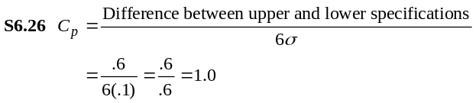
This process is barely capable.
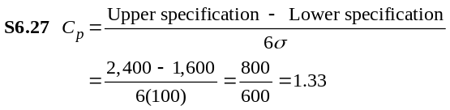
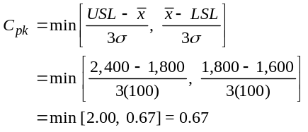
The Cp tells us the machine’s variability is acceptable relative to the range of tolerance limits. But Cpk tells us the distribution of output is too close to the lower specification and will produce chips whose lives are too short.
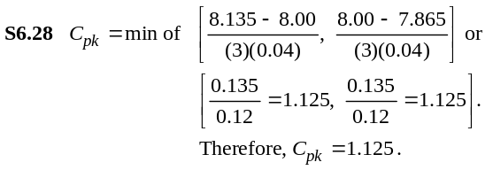
The process is centered and will produce within the specified tolerance.
S6.29 LSL = 2.9 mm, USL = 3.1 mm
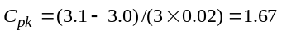
The upper specification limit lies about 5 standard deviations from the centerline, so practically 100 percent of the units will meet specifications.
S6.30
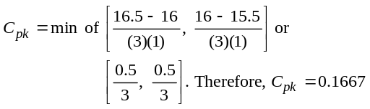
S6.31 Upper specification = 3.15, Lower specification = 2.85
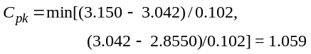
Since a value of 1.0 gives 2.7 defects per 1000 units, this means that the process is doing slightly better due to the fact that the Cpk is slightly larger than 1.0. This indicates that the process has at most 0.27% defective. Therefore, more than 99.73% of the bottles meet the specifications.
S6.32
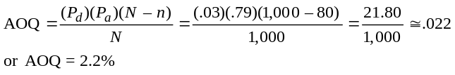
S6.33
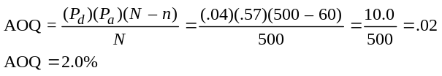
S6.34
(a) |  |  | Range
 | Upper Control Limit | 61.131 | 41.62
 | Center Line (avg) | 49.776 | 19.68
 | Lower Control Limit | 38.421 | 0.00

Recent Data Sample
Hour | 1 | 2 | 3 | 4 | 5 |  | R
26 | 48 | 52 | 39 | 57 | 61 | 51.4 | 22
27 | 45 | 53 | 48 | 46 | 66 | 51.6 | 21
28 | 63 | 49 | 50 | 45 | 53 | 52.0 | 18
29 | 47 | 70 | 45 | 52 | 61 | 57.0 | 25
30 | 45 | 38 | 46 | 54 | 52 | 47.0 | 16
(b) Yes, the process appears to be under control. Samples 26–30 stayed within the boundaries of the upper and lower control limits for both and R charts.
(c) The observed lifetimes have a mean of approximately 50 hours, which supports the claim made by West Battery Corp. However, the variance from the mean needs to be controlled and reduced. Lifetimes should deviate from the mean by no more than 5 hours (10% of the variance).
S6.35
(a) The overall percentage of late flights 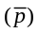 and the control limits are developed as follows:
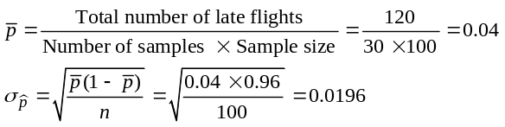
Then the control limits are given (for a 95% confidence interval; 95% = 1.96) by:
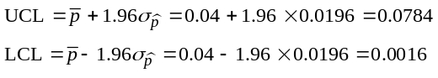
(b, c) Both the table presented in the left column below, and the control chart below indicate that the quality requirements of Alabama Airlines are more stringent than those of the airline industry as a whole. In five instances, the percentage of late flights exceeds the firm’s upper control limit; in two cases, the industry’s upper control limit is exceeded. An investigation, leading to corrective action, is clearly warranted.
Sample | Late Flights | Percentage of |  | Late Flights | Percentage
(n/100) | in Sample | Late Flights (n/100)* | Sample | in Sample | of Late Flights
1 | 2 | 0.02 | 16 | 2 | 0.02
2 | 4 | 0.04 | 17 | 3 | 0.03
3 | 10 | 0.10 | 18 | 7 | 0.07
4 | 4 | 0.04 | 19 | 3 | 0.03
5 | 1 | 0.01 | 20 | 2 | 0.02
6 | 1 | 0.01 | 21 | 3 | 0.03
7 | 13 | 0.13** | 22 | 7 | 0.07
8 | 9 | 0.09 | 23 | 4 | 0.04
9 | 11 | 0.11** | 24 | 3 | 0.03
10 | 0 | 0.00 | 25 | 2 | 0.02
11 | 3 | 0.03 | 26 | 2 | 0.02
12 | 4 | 0.04 | 27 | 0 | 0.00
13 | 2 | 0.02 | 28 | 1 | 0.01
14 | 2 | 0.02 | 29 | 3 | 0.03
15 | 8 | 0.08 | 30 | 4 | 0.04
*Boldfaced entries indicate sample fractions outside the quality control limits.
**Indicates sample fractions outside the industry standard quality control limits.

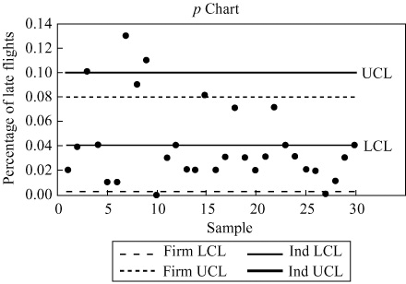

(d) Mike Hanna needs to report that his airline meets neither its own standards nor the industry standards.
Additional Homework Problems*
These homework problems appear on our web site www.myomlab.com.
S6.36 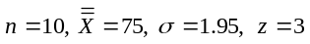
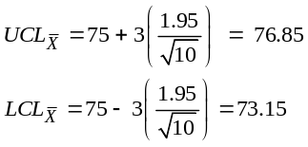
S6.37 n = 5. From Table S6.1, A2 = 0.577, D4 = 2.115, D3 = 0
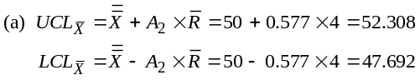
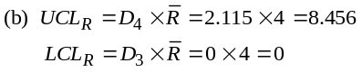
S6.38 n = 10. From Table S6.1, A2 = 0.308, D4 = 1.777, D3 = 0.233
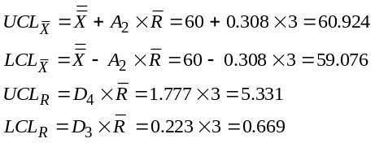
S6.39
Sample |  | R | Sample |  | R | Sample |  | R
1 | 63.5 | 2.0 | 10 | 63.5 | 1.3 | 19 | 63.8 | 1.3
2 | 63.6 | 1.0 | 11 | 63.3 | 1.8 | 20 | 63.5 | 1.6
3 | 63.7 | 1.7 | 12 | 63.2 | 1.0 | 21 | 63.9 | 1.0
4 | 63.9 | 0.9 | 13 | 63.6 | 1.8 | 22 | 63.2 | 1.8
5 | 63.4 | 1.2 | 14 | 63.3 | 1.5 | 23 | 63.3 | 1.7
6 | 63.0 | 1.6 | 15 | 63.4 | 1.7 | 24 | 64.0 | 2.0
7 | 63.2 | 1.8 | 16 | 63.4 | 1.4 | 25 | 63.4 | 1.5
8 | 63.3 | 1.3 | 17 | 63.5 | 1.1
9 | 63.7 | 1.6 | 18 | 63.6 | 1.8
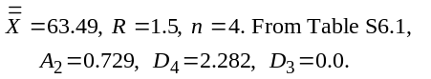
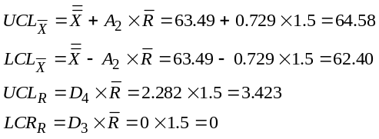

*Note to instructor: To broaden the selection of homework problems, these 17 problems are also available to you and your
students.

The process is in control.

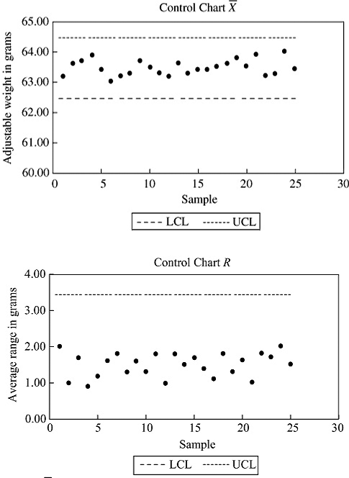

S6.40
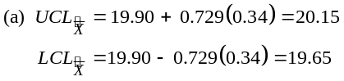
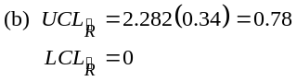
(c) The ranges are ok; the means are not in control
S6.41 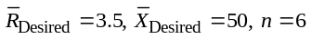
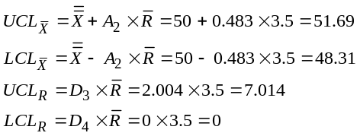
The smallest sample range is 1, the largest 6. Both are well within the control limits.
The smallest average is 47, the largest 57. Both are outside the proper control limits.
Therefore, although the range is with limits, the average is outside limits, and apparently increasing. Immediate action is needed to correct the problem and get the average within the con-trol limits again.
S6.42 0.51
_ _ _ _ _ _ _ _ _ _ _ _ _ _ _ _ _ 0.505 drill bit (largest)
_ _ _ _ _ _ _ _ _ _ _ _ _ _ _ _ _ 0.495 drill bit (smallest)
0.49
0.505 – 0.49 = 0.015, 0.015/0.00017 = 88 holes within
standard
0.495 – 0.49 = 0.005, 0.005/0.00017 = 29 holes within
standard
Any one drill bit should produce at least 29 holes that meet tolerance, but no more than 88 holes before being replaced.
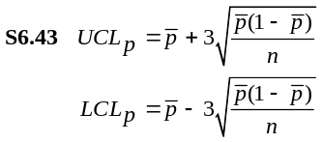
Percent |  | n = 200
Defective (p) | 1 – p | 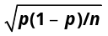 | 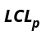 | 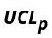
0.01 | 0.99 | 0.0070 | 0.0 | 0.0310
0.02 | 0.98 | 0.0099 | 0.0 | 0.0497
0.03 | 0.97 | 0.0121 | 0.0 | 0.0663
0.04 | 0.96 | 0.0139 | 0.0 | 0.0817
0.05 | 0.95 | 0.0154 | 0.0038 | 0.0962
0.06 | 0.94 | 0.0168 | 0.0096 | 0.1104
0.07 | 0.93 | 0.0180 | 0.0160 | 0.1240
0.08 | 0.92 | 0.0192 | 0.0224 | 0.1376
0.09 | 0.91 | 0.0202 | 0.0294 | 0.1506
0.10 | 0.90 | 0.0212 | 0.0364 | 0.1636

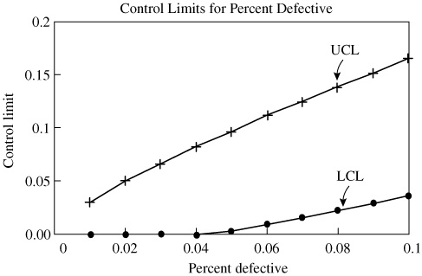
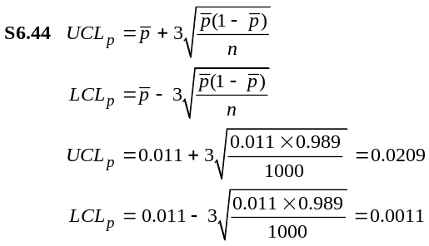

S6.45
 | Number |  | Number |  | Number
Day | Defective | Day | Defective | Day | Defective
1 | 6 | 8 | 3 | 15 | 4
2 | 5 | 9 | 6 | 16 | 5
3 | 6 | 10 | 3 | 17 | 6
4 | 4 | 11 | 7 | 18 | 5
5 | 3 | 12 | 5 | 19 | 4
6 | 4 | 13 | 4 | 20 | 3
7 | 5 | 14 | 3 | 21 | 7
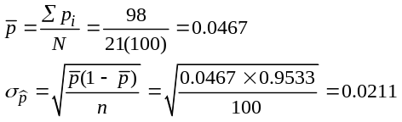
For a 3σ p-chart, the upper control level is given by:
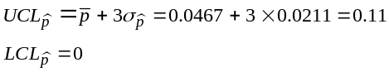
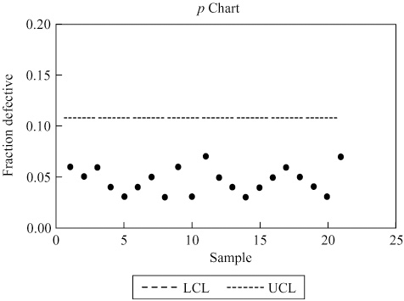
The process is in control.
S6.46 The following table provides the calculations for the
control limits:
Sample | Number of
No. | Defective Sinks | P-Value | In Control?
1 | 21 | 0.105 | Y
2 | 8 | 0.04 | Y
3 | 18 | 0.09 | Y
4 | 14 | 0.07 | Y
5 | 20 | 0.1 | Y
6 | 12 | 0.06 | Y
7 | 29 | 0.145 | Y
8 | 24 | 0.12 | Y
9 | 16 | 0.08 | Y
10 | 20 | 0.1 | Y
11 | 12 | 0.06 | Y
12 | 7 | 0.035 | Y
13 | 13 | 0.065 | Y
14 | 24 | 0.12 | Y
15 | 24 | 0.12 | Y
16 | 32 | 0.16 | N
17 | 12 | 0.06 | Y
18 | 16 | 0.08 | Y
19 | 21 | 0.105 | Y
20 | 26 | 0.13 | Y
21 | 28 | 0.14 | Y
22 | 22 | 0.11 | Y
23 | 17 | 0.085 | Y
24 | 14 | 0.07 | Y
25 | 12 | 0.06 | Y
p-bar = 0.0924
Std. Deviation of p = 0.020477
UCL_{p} = 0.154
LCL_{p} = 0.031
The process is not in control as sample 16 exceeds the UCL. When sample 16 is removed and the control limits recalculated, the process is in control, based on the data. This points out the importance of statistical sampling in process control.
S6.47
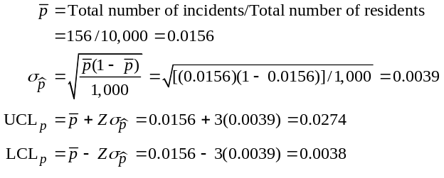
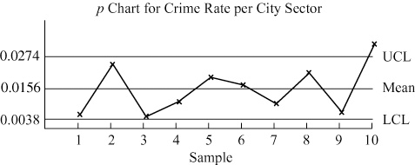
The p chart shows that the crime rate incidence in sector 10 is out of control. Police resources should be reallocated to those sectors with higher crime rates, specifically sector 10. Other information that may be helpful in the analysis would be:
(a) Description of each sector (business, residential, rural, inner city)
(b) Size of each sector (large, small)
(c) Location of precinct houses in relation to each sector
(d) Type (severity) of crime reported in each sector.
Note: To establish valid control limits, sample point 10 should be deleted and new, tighter control limits established.
S6.48
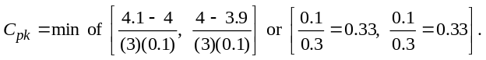
Therefore Cpk = 0.33. The process will not produce within the specified tolerance.

S6.49

Time | Box 1 | Box 2 | Box 3 | Box 4 | Average
9 am | 9.8 | 10.4 | 9.9 | 10.3 | 10.1
10 am | 10.1 | 10.2 | 9.9 | 9.8 | 10.0
11 am | 9.9 | 10.5 | 10.3 | 10.1 | 10.2
12 pm | 9.7 | 9.8 | 10.3 | 10.2 | 10.0
1 pm | 9.7 | 10.1 | 9.9 | 9.9 | 9.9
 |  |  |  | Average= |  | 10.04
 |  |  |  | Std. Dev. = | 0.11
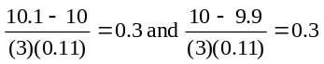
As 0.3 is less than 1, the process will not produce within the specified tolerance.
S6.50 Machine One produces “off-center” with a smaller standard deviation than Machine Two. Machine One has index of 0.83, and Machine Two has an index of 1.0. Thus Machine One is not capable. Machine Two is capable.
Machine 1
Parameter | Value | Results | Value
Upper tolerance | 0.403 | Process capability | 0.8333
limit |  | index
Lower tolerance | 0.4 | Upper one | 1.6667
limit |  | sided index
Mean | 0.401 | Lower one | 0.8333
 |  | sided index
Standard deviation | 0.0004
Machine 2
Parameter | Value | Results | Value
Upper tolerance limit | 0.403 | Process capability Index | 1
Lower tolerance limit | 0.4 | Upper one sided index | 1
Mean | 0.4015 | Lower one sided index | 1
Standard deviation | 0.0005
S6.51 The capability index is 1.33 on the upper and lower end. The process is capable.
Parameter | Value | Results | Value
Upper tolerance limit | 1.04 | Process capability index | 1.333
Lower tolerance limit | 0.96 | Upper one sided index | 1.333
Mean | 1 | Lower one sided index | 1.333
Standard deviation | 0.01
S6.52
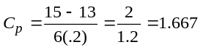
This is a very capable process.

Case Studies
BAYFIELD MUD COMPANY
1. The first thing that must be done is to develop quality control limits for the sample means. This can be done as follows. Because the process appears to be unstable, we can use the desired mean as the nominal line. Desired = 50.0, σ = 1.2 (from past results of Wet-Land Drilling), 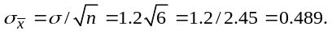 At a 99.73% confidence interval Z = 3:
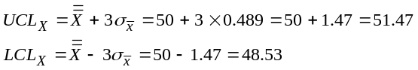
Now that we have appropriate control limits, these must be applied to the samples taken on the individual shifts:
Day Shift*
Time | Ave | Low | High | Ave | Low | High | Ave | Low | High
6:00 | 49.6 | 48.7 | 50.7 | 48.6 | 47.4 | 52.0 | 48.4 | 45.0 | 49.0
7:00 | 50.2 | 49.1 | 51.2 | 50.0 | 49.2 | 52.2 | 48.8 | 44.8 | 49.7
8:00 | 50.6 | 49.6 | 51.4 | 49.8 | 49.0 | 52.4 | 49.6 | 48.0 | 51.8
9:00 | 50.8 | 50.2 | 51.8 | 50.3 | 49.4 | 51.7 | 50.0 | 48.1 | 52.7
10:00 | 49.9 | 49.2 | 52.3 | 50.2 | 49.6 | 51.8 | 51.0 | 48.1 | 55.2
11:00 | 50.3 | 48.6 | 51.7 | 50.0 | 49.0 | 52.3 | 50.4 | 49.5 | 54.1
12:00 | 48.6 | 46.2 | 50.4 | 50.0 | 48.8 | 52.4 | 50.0 | 48.7 | 50.9
1:00 | 49.0 | 46.4 | 50.0 | 50.1 | 49.4 | 53.6 | 48.9 | 47.6 | 51.2

Evening Shift
Time | Ave | Low | High | Ave | Low | High | Ave | Low | High
2:00 | 49.0 | 46.0 | 50.6 | 49.7 | 48.6 | 51.0 | 49.8 | 48.4 | 51.0
3:00 | 49.8 | 48.2 | 50.8 | 48.4 | 47.2 | 51.7 | 49.8 | 48.8 | 50.8
4:00 | 50.3 | 49.2 | 52.7 | 47.2 | 45.3 | 50.9 | 50.0 | 49.1 | 50.6
5:00 | 51.4 | 50.0 | 55.3 | 46.8 | 44.1 | 49.0 | 47.8 | 45.2 | 51.2
6:00 | 51.6 | 49.2 | 54.7 | 46.8 | 41.0 | 51.2 | 46.4 | 44.0 | 49.7
7:00 | 51.8 | 50.0 | 55.6 | 50.0 | 46.2 | 51.7 | 46.5 | 44.4 | 50.0
8:00 | 51.0 | 48.6 | 53.2 | 47.4 | 44.0 | 48.7 | 47.2 | 46.6 | 48.9
9:00 | 50.5 | 49.4 | 52.4 | 47.0 | 44.2 | 48.9 | 48.4 | 47.2 | 49.5

Night Shift
Time | Ave | Low | High | Ave | Low | High | Ave | Low | High
10:00 | 49.2 | 46.1 | 50.7 | 47.2 | 46.6 | 50.2 | 49.2 | 48.1 | 50.7
11:00 | 49.0 | 46.3 | 50.8 | 48.6 | 47.0 | 50.0 | 48.4 | 47.0 | 50.8
12:00 | 48.4 | 45.4 | 50.2 | 49.8 | 48.2 | 50.4 | 47.2 | 46.4 | 49.2
1:00 | 47.6 | 44.3 | 49.7 | 49.6 | 48.4 | 51.7 | 47.4 | 46.8 | 49.0
2:00 | 47.4 | 44.1 | 49.6 | 50.0 | 49.0 | 52.2 | 48.8 | 47.2 | 51.4
3:00 | 48.2 | 45.2 | 49.0 | 50.0 | 49.2 | 50.0 | 49.6 | 49.0 | 50.6
4:00 | 48.0 | 45.5 | 49.1 | 47.2 | 46.3 | 50.5 | 51.0 | 50.5 | 51.5
5:00 | 48.4 | 47.1 | 49.6 | 47.0 | 44.1 | 49.7 | 50.5 | 50.0 | 51.9
* Boldfaced type indicates a sample outside the quality control limits.
(a) Day shift (6:00 am–2:00 pm):
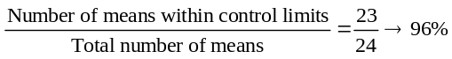
(b) Evening shift (2:00 pm–10:00 pm):
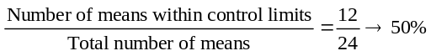

(c) Night shift (10:00 pm–6:00 am):
As is now evident, none of the shifts meet the control specifi-cations. Bag weight monitoring needs improvement on all shifts. The problem is much more acute on the evening and night shifts staffed by the more recent hires.
Note also, that the number of samples indicating a “short weight” is much greater than the number indicating excess weight.
With regard to the range, 99.73% of the individual bag weights should lie within ±3σ of the mean. This would represent a range of 6σ, or 7.2. Only one of the ranges defined by the differ-ence between the highest and lowest bag weights in each sample exceeds this range. Alternatively: D4 × Sample Range = UCLR and D2 × Sample Range = LCLR. This is dangerous if the process is out of control, but the mean range for the first shift is 3.14 (the lowest of any shift) and D4 × 3.14 = 6.28 and D3 × 3.14 = 0. A range of 0 to 6.28 compares favorably with 7.2, with only two values exceeding the range limit. It would appear, then, that the problem is not due to abnormal deviations between the highest and lowest bag weights, but rather to poor adjustments of the bag weight-feeder causing assignable variations in average bag weights.
2. The proper procedure is to establish mean and range charts to guide the bag packers. The foreman would then be alerted when sample weights deviate from mean and range control limits. The immediate problem, however, must be corrected by additional training and bag weight monitoring and weight-feeder adjust-ments. Short-run declines in bag output may be necessary to achieve acceptable bag weights.
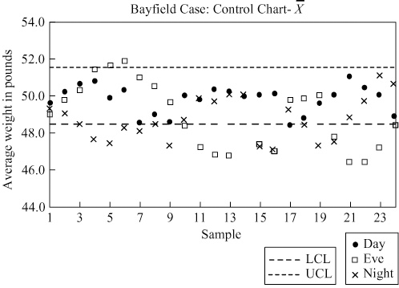

Video Case Studies
FRITO-LAY’S QUALITY-CONTROLLED
POTATO CHIPS
1
Note to instructors: Here is a real-world case of a company whose products are known to every student. We suggest you show this video in class as a basic tutorial on how to create an SPC chart from scratch. The video walks students through the factory and the statistical aspects of control charts.
- The video shows how the 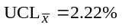 and 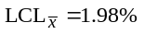 are developed for salt content of Lay’s chips. The population standard deviation, from the video, is σ = .07, which we will use on the new data. The 5 sample means are 2.075, 2.015, 2.1375, 2.1, and 2.0975 for samples 1–5, respectively. 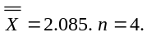
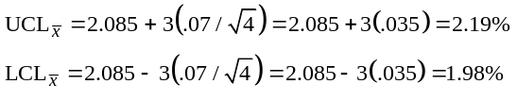
These new limits will be acceptable as they are even tighter than the original delivery process for salt content.
- Frito-Lay drivers deliver and stock supermarket shelves.
Advantages: (a) Control over shelf appearance—they always straighten all bags/displays with every visit; (b) immediate sales feedback; (c) awareness of competition; and (d) always in stock—no lost sales.
Disadvantages: (a) Expensive and time-consuming for drivers to act as store clerks.
3. Quality drives this consumer product. The taste of each chip or other snack must be the same every bite. The bags must be identical in weight and appearance. The product must be fresh. Every step in production—from farm to factory—needs to meet specifications. Quality is measured on dozens of measures and monitored throughout the plant with SPC charts and computer process controls.
FARM TO FORK: QUALITY AT DARDEN
RESTAURANTS
2
1. It is not by chance the Darden calls its food quality program “Farm to Fork.” The Farm to Fork program is a comprehensive program that addresses quality from a) the food source via evaluation, selection, development of sources; to b) similar commitment along the processing and logistics chain; to c) standards for delivery, preparation, and serving at the restaurant. This includes hygiene and monitoring both the hot and cold temperature standards along each step to delivery to the final customer’s fork.
2. Many options in any restaurant exist for fishbone analysis. These include customer satisfaction, employee performance, meal quality, and delivery quality. In the solutions of Chapter 6, we presented several fishbone charts that can provide a starting point for quality analysis in a restaurant:
- For the dissatisfied restaurant customer, see Solution 6.8, “A Dissatisfied Airline Customer”
- For the problem employee, see Solution 6.9, “Getting to Work Late”
- For the incorrect bill, see Solution 6.11, “Incorrect Fee Statement”
- For problems in food prep, see Solution 6.14, “Incorrect Formulation”
- For problems with delivery, see Solution 6.16d, “Increasing Defective Shipments”
3. Darden uses attribute sampling to evaluate product size (shrimp too large or too small), number of products not maintained at the proper temperature, etc.
4. Observations from the data:
- The mean weight 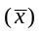 is within the upper and lower pro-
cess means.
- The range 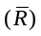, with the exception of sample 11, is within the control limits. Note that sample 11 had a problem as it is out of range on the R chart and at the minimum on
the chart.
- With C_{p} at 1.77 and C_{pk} at 1.7, process capability is above the 5 sigma (1.67 C_{pk} is 5 sigma) level, well within the de-sired specifications of 10 and 12.
- The supplier is meeting the specifications very easily.
Taken together, the analysis suggests a strong capability and a good process. Sample 11 warrants some evaluation, but the report should suggest an excellent process, and you tell the vendor to keep up the good work.

Additional Case Study*
GREEN RIVER CHEMICAL CO.
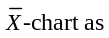This is a very straightforward case. Running software to analyze
the data will generate the
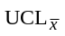: 61.13
(Center line) Nominal: 49.78
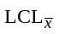: 38.42
and the range chart as
UCLR : 41.62
(Center line) Nominal: 19.68
LCLR : 0.00
Next, students need to take the means and ranges for the five additional samples:
Date |  | Mean | Range
April | 6 | 52 | 18
 | 7 | 57 | 25
 | 8 | 47 | 16
 | 9 | 51.4 | 22
 | 10 | 51.6 | 21
The mean and the ranges are all well within the control limits for this week. There is, however, a noticeable change in the original data at time 13, where the range suddenly dropped. It then goes back up at time 17. The data were generated by students in class, and changes in the process were made at the aforementioned times. The control chart identifies that these changes took place.

*This case study is found at both our Companion Web site, at www.pearsonhighered.com/heizer, and at www.myomlab.com.

